# WebFOCUS 8 Repository Reports

The reports under ‘Users and Groups’ and ‘Repository Content’ can run against any level of WebFOCUS 8.x, on any platform and against any type of repository (MS SQL Server, Oracle, DB2, etc.).

## Users and Groups

|  |  |
| --- | --- |
| Group Membership Count   * Shows the count of users by group * Drills to the Group Membership List drill down report | GroupMembershipCount.fex  Tables:  UOA_GROUPS  UOA_GROUPSUSERS |
| Group Membership List drill down   * Shows the listing of users in a single group | GroupMembershipListdrilldown.fex  Tables:  UOA_GROUPS  UOA_GROUPSUSERS  UOA_USERS |
| Group Membership by userid   * Shows userid, user name, and all groups each user belongs to * Active Report – sort and filter your own way | groupmembershiplist_by_userid.fex  Tables:  UOA_GROUPS  UOA_GROUPSUSERS  UOA_USERS |

## Repository Content

|  |  |
| --- | --- |
| Inventory of Objects   * Lists all items in Content area, sorted by Path, columns Description, OBJ_Handle, Last Modified By, Last Modified on, ItemType * Active Report – sort and filter your own way | RepositoryInventory.fex (and FexList.sql)  Tables:  WF_REPOSOBJ  WF_NLSOBJ  WF_ITEM  WF_CONTENT_REVS |
| Items Changed Since   * Lists all items that have been updated since a certain date (user specifies the date) * Active Report – sort and filter your own way | ItemsChangedSince.fex  Prompt: Date  Tables:  WF_REPOSOBJ |

## Search Utility

|  |  |
| --- | --- |
| Search for a string within repository items   * Lists all items where a given string is present in the code (prompts user for string value) * String value – ok to contain spaces, & * This utility supplies sets of code that work only against a SQL Server or Oracle repository; code will need to be altered to work for DB2 or other type repository (looking for contributors for DB2 and other repository types) | search_for_string_in_code.fex  search_for_string_in_code_oracle.fex  Note – this uses SQL SELECT code, not FOCUS code  Tables:  WF_CONTENT_REVS  WF_REPOSOBJ |

## WebFOCUS Environment Setup

1. Create a Connection on your WebFOCUS Reporting Server to the WebFOCUS 8 repository named: **WF_Repository**
   1. The userid used in this connection **WF_Repository** must have SELECT authority to the tables in the repository database.
   2. Important: A best practice (for security and protection of the WebFOCUS repository) is that you use a different userid than the repository owner (dbo) or schema name, because these userids will have full authority to the tables (including INSERT/UPDATE/DELETE). Recommendation is to consult with your WebFOCUS Administrator and DBA to establish a separate userid that has only SELECT authority to the WebFOCUS 8 repository tables.
2. Create an app folder called ‘**repository**’; add this directory to the server’s **APP PATH** (at the end is OK)
3. Create synonyms in the ‘**repository**’ app for the following tables:

**UOA_GROUPS**

**UOA_GROUPSUSERS**

**UOA_USERS**

**WF_REPOSOBJ**

**WF_NLSOBJ**

**WF_ITEM**

**WF_CONTENT_REVS**

1. Unzip the package of utility reports (**repository.zip**) to your WebFOCUS Reporting Server apps folder ‘**repository**’ (e.g. **D:\ibi\apps\repository**)
2. **If your repository is Oracle instead of SQL Server**, then rename the file ‘**search_for_string_in_code.fex**’ to ‘**search_for_string_in_code_MSSQL.fex**’, and also rename the file ‘**search_for_string_in_code_oracle.fex**’ to ‘**search_for_string_in_code.fex**’.
3. The package includes a launch page called ‘**menu.htm**’, which is a convenient way to run the reports.
   1. If your WebFOCUS environment is split tier (web server and Reporting Server on different hosts), then put the ‘**menu.htm**’ file on your web server and the other files on the Reporting Server.
   2. For a single tier environment (web server and Reporting Server on the same host), then leave ‘**menu.htm**’ in place.
   3. The URL to launch this menu is:

[**http://*hostname*/approot/repository/menu.htm**](http://hostname/approot/repository/menu.htm)

1. Note that you can also run the Repository utility reports individually (names listed on page 1) from the Reporting Server Console (if your userid has access to the Applications section in the Server Console).

## Example outputs

### Group Membership Count

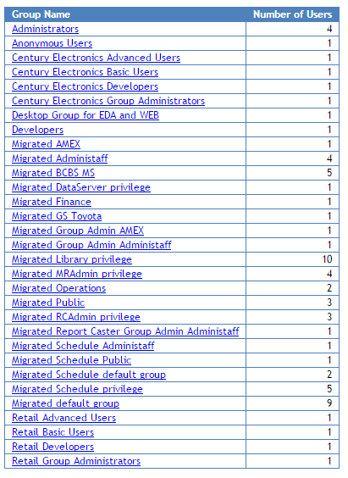

Drill on a group to see the users in the group (the ‘Group Membership List drill down’ report):

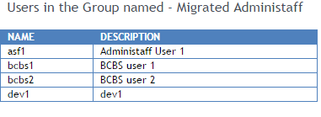

### Group Membership List by Userid

* This report shows all the groups of ALL users.
* The same information for an individual user can be shown in the Security Center in the Group Membership Report.

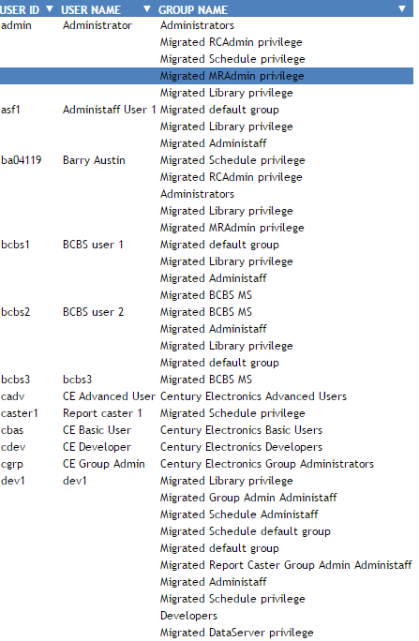

### Repository Content

* An inventory of all repository items
* Active report – sort and filter any way desired

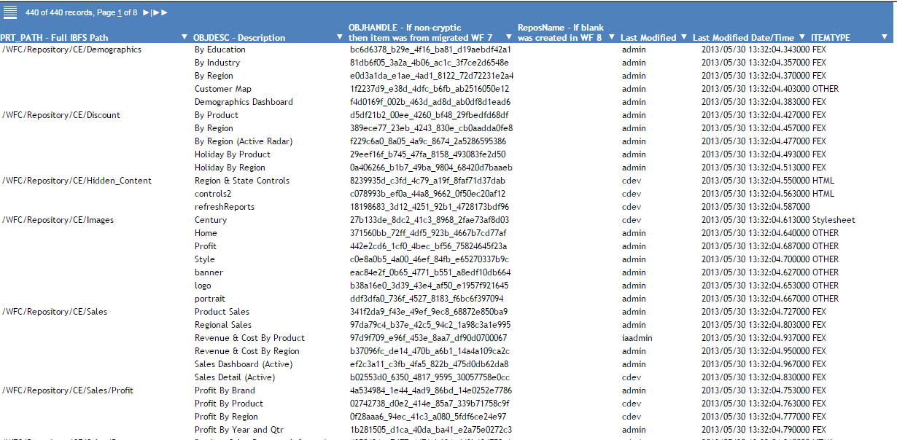

Note: the final column ITEMTYPE is a defined column.

#### Content created under WebFOCUS 8

The example output above consists of content that was created in WF 8. Note that the **OBJHANDLE** field is non-blank and cryptic, and the **ReposName** field is blank.

The example below shows the **ReportCaster** content (migrated from WF 7) but the **OBJHANDLE** field is non-blank and cryptic, and the **ReposName** field is blank. Note that the first column (PRT_PATH field) indicates the ownerid of the schedule (e.g. admin) at the end of the displayed string.

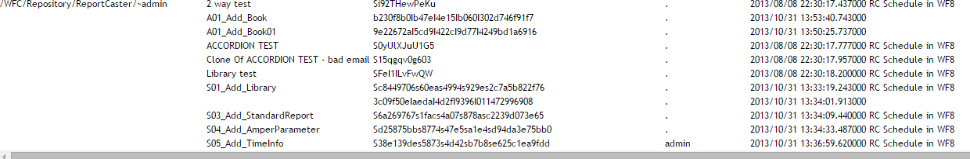

#### Content Migrated from WebFOCUS 7

The next example shows a migrated WF 7 domain ‘administ’ and its contents. Note that the **OBJHANDLE** field (3rd column) is non-cryptic and reflects the WF 7 notation of the domain (‘administ|app’) prefixing the item name. The **ReposName** field (4th column) is non-blank.

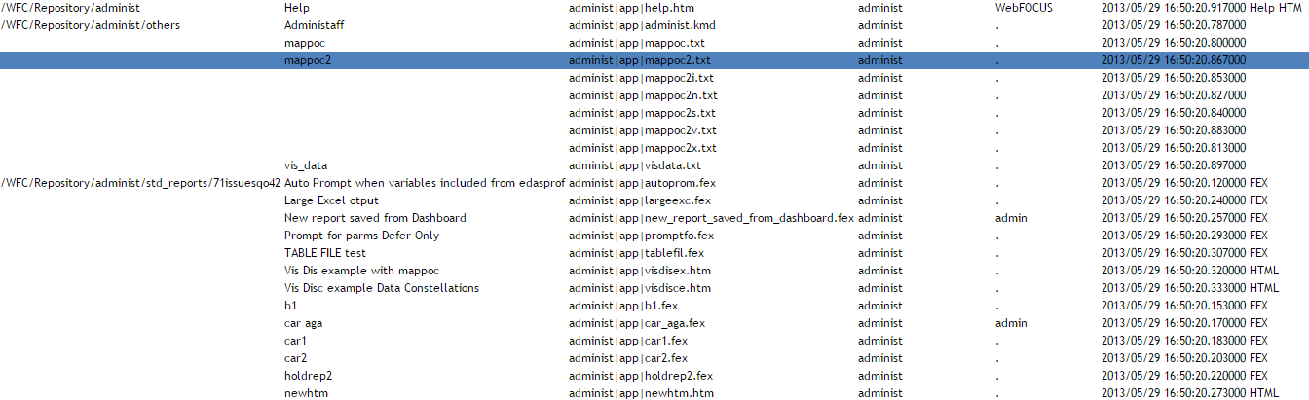

Other observations:

* The Last Modified column (column 5) has the value ‘WEBFOCUS’ for help files that were migrated from WF 7.

### 

### Items Changed Since

* Specify the date in the box below the ‘Items Changed Since’ button
* The date can be specified as either MM/DD/YYYY or YYYY/MM/DD format (or without the / characters)
* This can be a very useful report when creating Change Management export packages!

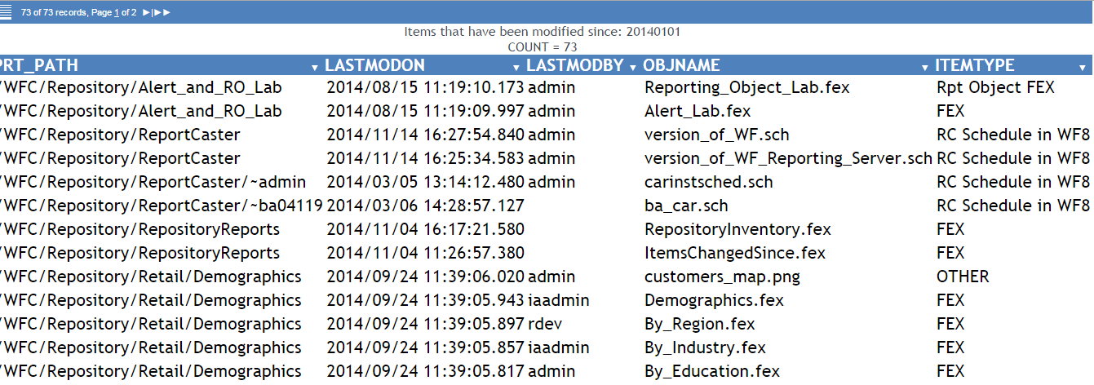

### Search for a string within repository items

* In WebFOCUS 7, you were able do a string search against the location in the file system (**basedir** folder) to locate strings within FEX’s or HTML code. In a WebFOCUS 8 environment, this type of search must be done via a query because these elements are now stored in a database table in a binary object field (BLOB).
* This report is only meant to help you locate items containing a given text string. To see or edit the code, you must use the traditional method (edit in Portal, or text editor in Dev Studio or App Studio)
* **The utility will not work unless the repository is MS SQL Server or Oracle; updates for DB2 repositories and others are anticipated to come soon (looking for your expertise to help for DB2 and other repository types)**
* Output shows only the location of the item (IBFS path)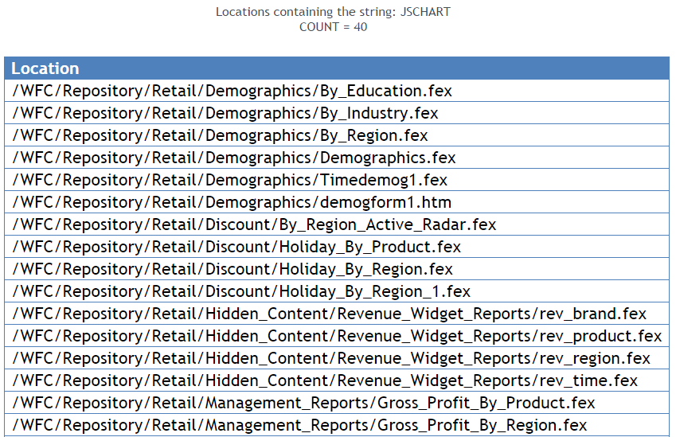

#### Example Use Cases

|  |  |
| --- | --- |
| Hard coded server names, path names, file names etc. contained in FEX’s or HTML items | D:\ibi\apps\finance\  <http://wf77prod/>  logo.gif  logo.jpg |
| WebFOCUS specific syntax | GRAPH FILE  FILEDEF  -SET &ECHO=ALL;  -SET &ECHO=ON;  -SET &ECHO = ALL ; |
| Any string at all | A person’s name or initials may appear within comments  A special color name (or HEX representation) mentioned in a stylesheet, e.g. Blue  A particular & variable name  A particular SET command |